**Super Market Sales Data Analysis**

**Interpretation of Graphs and Statistical Results**

1. **Histogram:**

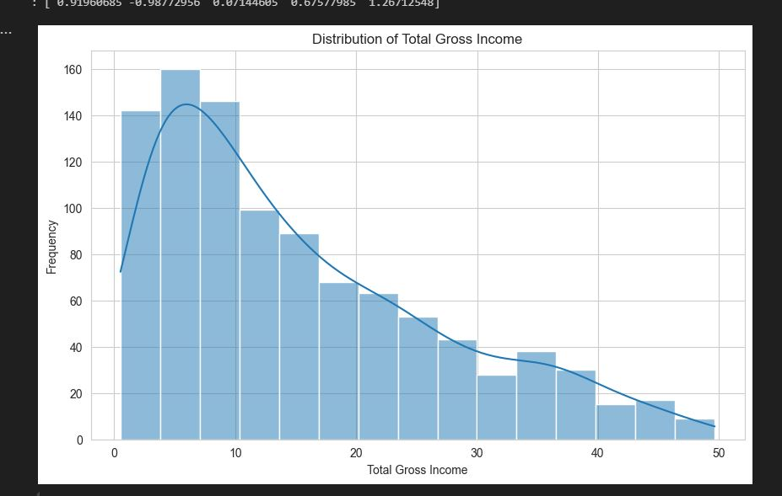

**X-axis**: Total Gross Income: The Income Values.

**Y-axis**: Frequency: How many times income range appears in the dataset.

**Bars**: Histogram showing how income values are distributed.

**Blue curved line**: KDE: a smoothed line that helps us visualizes the shape of the distribution.

**Interpretation:**

1. **Right-Skewed Distribution**:

* The curve **peaks on the left** and **tails off to the right**.
* This tells us the data is **right-skewed** or **positively skewed**.
* Most customers have **lower gross income**, and fewer have **very high gross income**.

1. **Mode (Most Frequent Range)**:

•The **tallest bar** is around 5–10 on the x-axis.

•This is the **most common range** of total gross income

1. **Fewer High-Income Entries**:

As income increases, the number of customers decreases.

Very **few entries exist** above 30 or 40.

**What can we say overall?**

Most sales result in **low to moderate income**, with a **small number of high-value transactions**.

If you're analyzing business performance, this might mean:

•Your product is affordable for many customers (good).

• High-ticket sales are rare and could be a growth opportunity

.

1. **Boxplot**

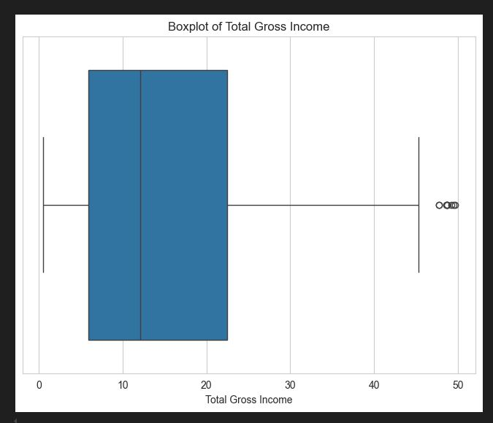

**What a Boxplot Shows**

A boxplot summarizes data using **5 key numbers**:

1. **Minimum** (excluding outliers)
2. **1st Quartile (Q1)** — 25% of data is below this
3. **Median (Q2)** — 50% of data is below this (the middle value)
4. **3rd Quartile (Q3)** — 75% of data is below this
5. **Maximum** (excluding outliers)

It also shows **outliers** — unusually high or low values.

### Interpretation of This Plot

* **The thick box** in the center shows the **middle 50%** of the data (between Q1 and Q3).
* The **line inside the box** is the **median** (middle value) — looks to be around **13–15**.
* **Whiskers** (the lines extending from the box) represent the typical range of the data.
* **Small circles on the right** are **outliers** — these are customers with **unusually high gross income**.

**What it means:**

* Most of the transactions have gross incomes between around **5 and 30**.
* A few sales went above **40**, but those are **outliers**, not common.
* The **distribution is right-skewed** (longer tail on the right), meaning most sales are smaller, and a few are much larger.

**Simple Summary:**

* Most sales bring in a **low to moderate gross income**, with **some rare high-value sales** (the outliers).